TAIBAI SHAN - an Eldorado for some HARDY & RARE RHODODENDRONS

In beginning of June 2004 I spent four days high up in the subalpine and alpine eco-zones in Taibai Shan Shaanxi mainly in altitudes between 2800-3500m a.s.l. The Taibai Mts. belongs to the 1500 km long mountain range of Qinling which is a physical barrier between north and south China. It also divides the cool temperate flora from north to the warm tempered or subtropic al flora from the south. In Qinling the Taibai Mountains have the highest peak, 3767 meters at sea level. The slopes of different elevations in combination with local climates and the impact from lowlands around give Taibai Shan an outstanding biodiversity. Here we find for example a flora full of endemic species. Two rhododendrons are quite new, Rhododendron taibaiense (Ching & H.P.Yang, 1983) in the subsection LAPPONICA and Rhododendron aureodorsale (W.P. Fang ex J.Q. Fu) Y.P. Ma & J. Nielsen, 2012) in subsection TALIENSIA. Except these species I found another two rhododendrons in elevations around 3000 to 3500m, the beautiful Rhododendron purdomii and the dwarf Rhododendron capitatum. In lower elevations around 2800-3000m there were another two, the common Rhododendron concinnum and a more sparsely Rhododendron pachytrichum. Some shrubs of R. concinnum were here - at the time - quite bluish but mostly ordinary purple. All species except R. pachytrichum I saw in bloom (from June 2-5th). My Chinese botanist colleagues presented the large shrub or small tree with white blooms as Rhododendron clementinae. I and friends from the Swedish University of Agricultural Sciences who took part in the expedition were a bit confused. Later, after consultations with the literature we found it described as a subspecies R. clementinae ssp. aureodorsale (W. P. Fang ex J. Q. Fu, 1983). We were still doubtful to the classification but eight years later botanists from Kunming Botanical Garden and the Dane Jens Nielsen made a new combination, Rhododendron aureodorsale. Though few people (rather than Chinese tourists and militants) have seen mature plants blooming and their wild habitat I publish at long last some photos from my expedition 2004. This may add some useful information about the species. As well as I noticed a few individuals haven't the pure white blooms with many crimson dots but instead they were rose-tinted (sometimes strongly). In distance these shrubs or small trees looked pale rose. In general the species is a strong growing shrub but a few were trees up to 7-8 meters with single stems. The climate in the growing area at that high is severe. You even find snow sometimes in July. I think all rhododendrons mentioned here are very tough and cold hardy maybe down to minus 25 degrees C or less.
Sten Ridderlöf, Stockholm Sweden March 15, 2015.

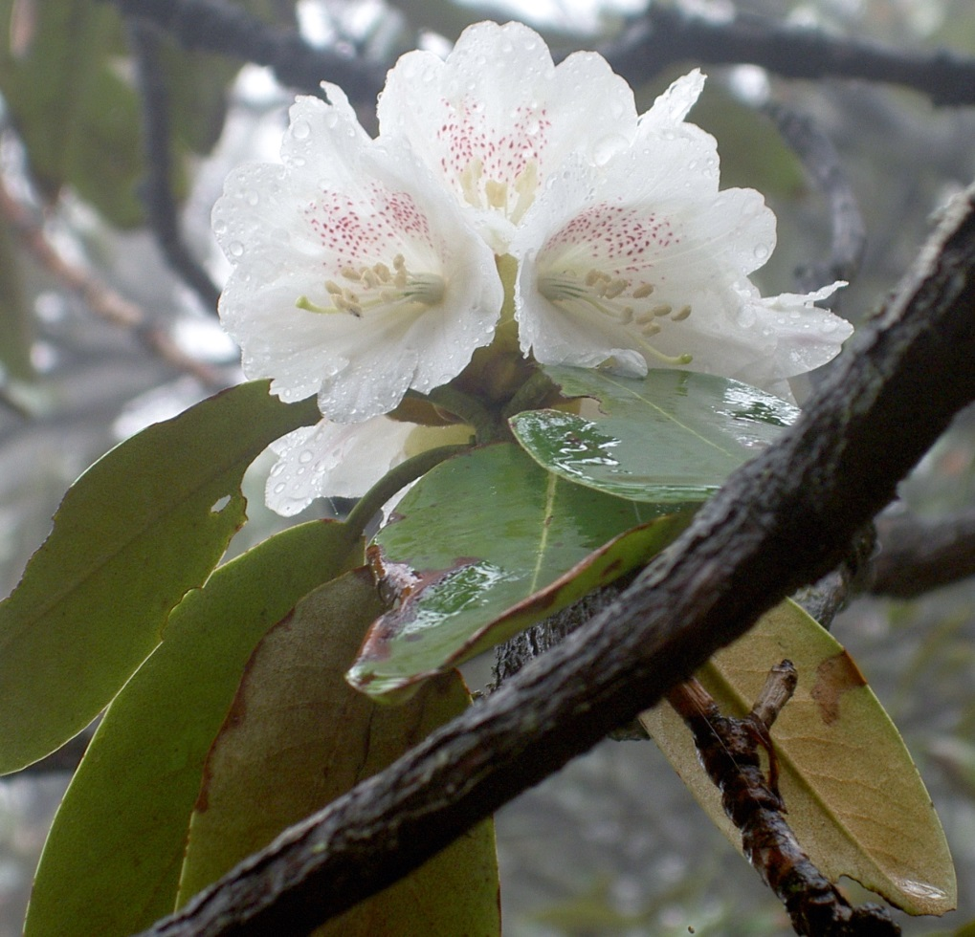
Photo 1: Rhododendron aureodorsale (white form) Taibai Shan 3400m a.s.l. Shaanxi China June 3, 2004 Image S. Ridderlöf
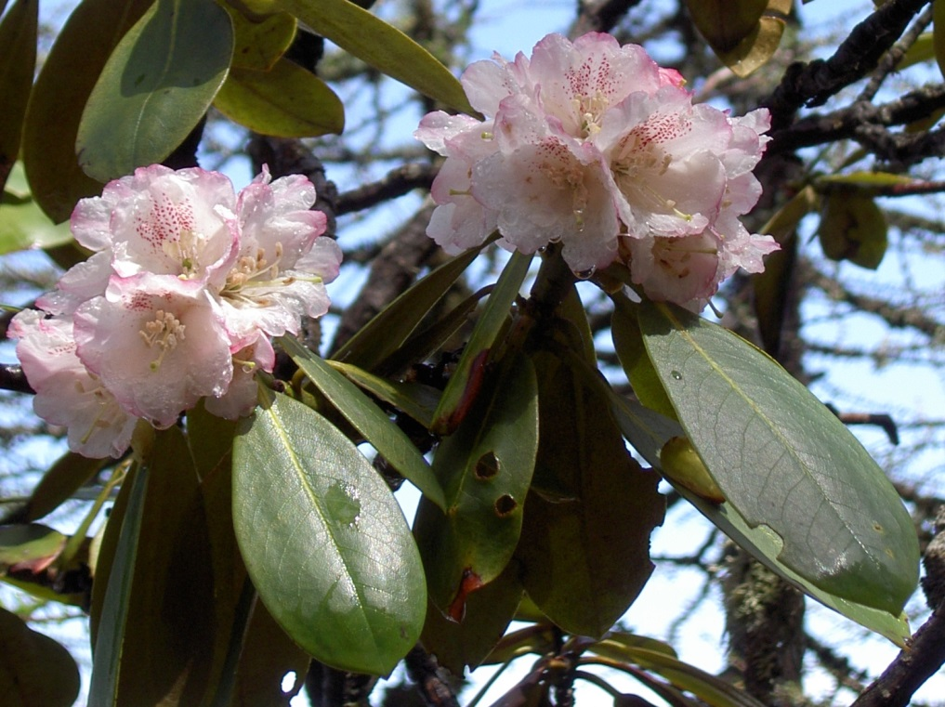
Photo 2: Rhododendron aureodorsale (rose-tinted form) Taibai Shan 3500m a.s.l. Shaanxi China June 5, 2004 Image S. Ridderlöf
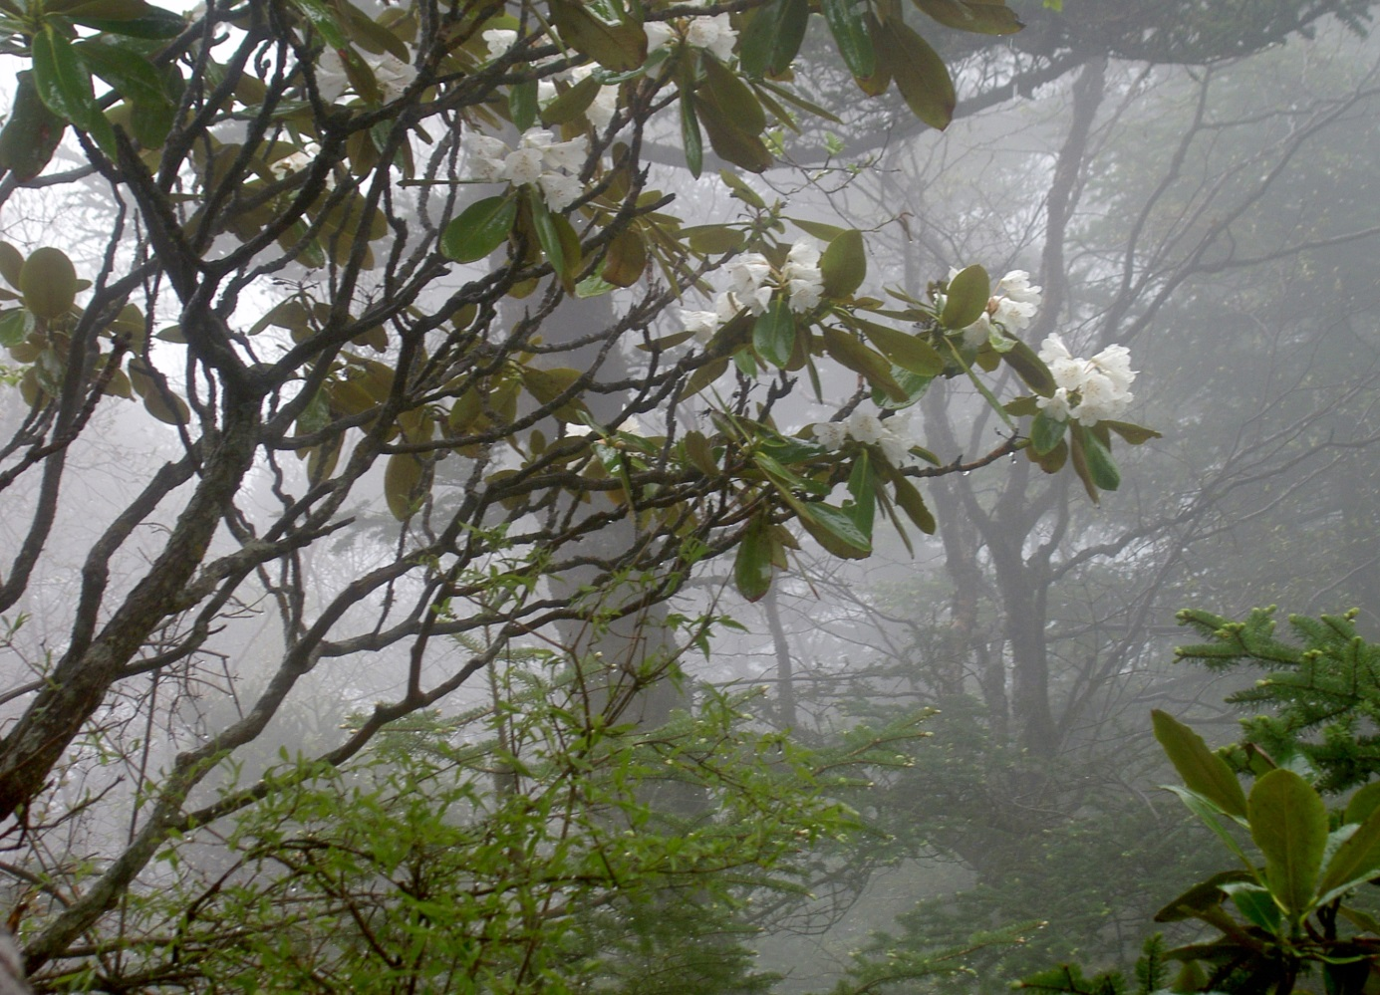
Photo 3: Part of a small tree Rhododendron aureodorsale (white/normal colours) Taibai Shan 3400m a.s.l. Shaanxi China June 3, 2004 Image S. Ridderlöf
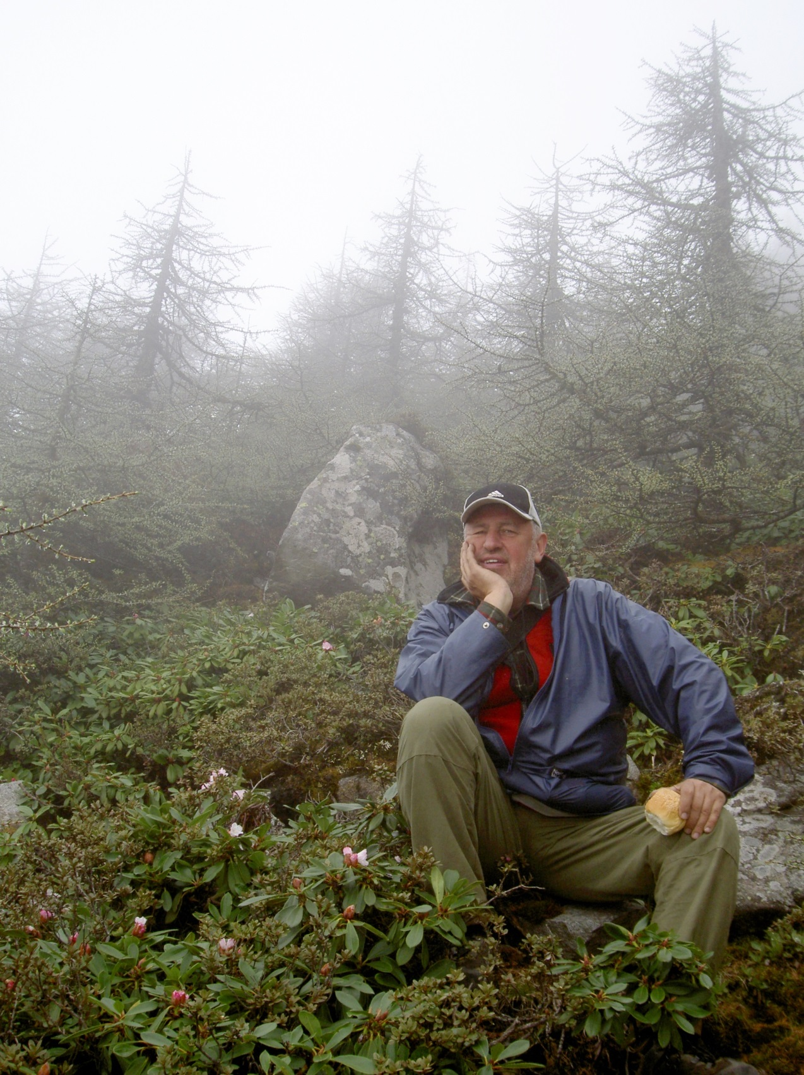
Photo 4: A hungry and tired Sten Ridderlöf among Rhododendron purdomii & Rhododendron taibaiense and Larix chinensis Taibai Shan 3500m a.s.l. Shaanxi China June 5, 2004 Image H. Sjöman

